NamanganviloyatiKosonsoytumani
53-umumta’limmaktabiIngliztilifanio‘qituvchisi
QodirovAdhamjonning
2019-2020-o‘quvyili IV choragida
9-sinflarning online darslaribo‘yichayozgan

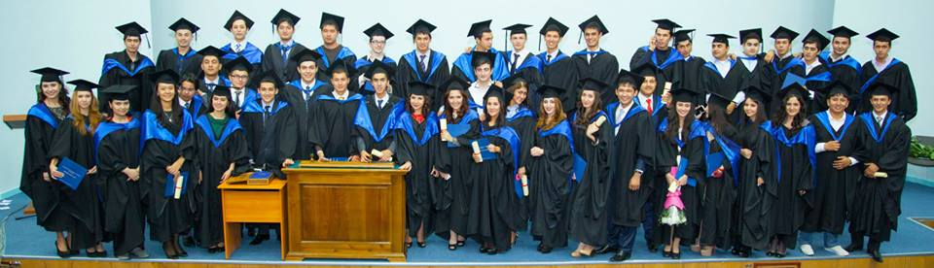

Namangan -2020

9 – sinf
№ | Date | Subject | Theme | Thesis | Homework
1 | 30.03.2020 | English | We have had our house painted | New vocabulary: house, wash, smart, iron, repair, clever  Have something done  Biz ‘have something done’ nibirorshaxsgaqandaydirishniqildirtirayotganimizniaytishuchunishlatamiz. Bu iboraningtuzilishiquyidagichadir:  have + to‘ldiruvchi+ o‘tganzamonsifatdoshi. (0‘tgan zamonsifatdoshife’llariga 121- betgaqarang). have to'ldiruvchio‘tganzamonsifatdoshi  m-n. I had my hair cut. | Write 50sentences for Present Perfect
2 | 01.04.2020 | English | Atthehairdresser | to introduce and practise ‘I wish’ + Past Simple to express regrets about things which are true now; to practise the new vocabulary. Read the example in the exercise and explain the meaning and the form. You could also ask them to look at the Grammar Reference, if you feel this would be helpful. Then let PP  do the exercise. It is a very simple one. | Make an appointment. Write dialoge
3 | 03.04.2020 | English | At the hairdresser (consolidation) | to give further practice with ‘1 wish’ + Past Perfect to express regrets about things which happened in the past and cannot be changed This is quite a challenging activity and if you have a weak class it may be better to omit it. Read the example in the exercise and explain the meaning and the form. You could also  ask them to look at the Grammar Reference, if you feel this would be helpful. Then let PP do the exercise | Write 10 sentences
4 | 06.04.2020 | English | I’ve broken my heel | to give further practice with the new vocabulary; to practice ‗something needs doing‘ look at their shoes and comment on their condition using the table and the example to help them. You could draw PP attention to the structure in the Remember box if you think they do not know the structure already. Check they understand the meaning of the structure. You could ask them to translate the sentence in the Remember box. | Something + need + doing write sentences
5 | 08.04.2020 | English | Industry in Uzbekistan | New words: reserve, raw materials, cotton, car, fertilize, airplane, agro-chemical, textile, manufacture topractise reading for gist # read the leaflet and match the headings and the paragraphs. Key: 1 b 2c 3d 4e 5a | Learning business vocabulary
6 | 11.04.2020 | English | Industry in Uzb (cons) | to introduce and practise word formation  Read the text again and find all the words with the same root as ‗export‘, etc. and translate them. Then ask them to make new words with suffixes -er, -or, -tion from: import, invest, construct, associate, attract, create, manufacture and write them down in their Ex.Bks. Ask them to translate the words.  Key: importer, investor, creator, manufacturer, constructor, association, creation, attraction, construction | Noun + suffixes
9 | 13.04.2020 | English | Industry in the UK and the USA | New words: machine, chemical, light, shipbuilding, atom, food, electronic, silkworm, cotton cleaning, aircraft, poultry farming  to prepare for reading  Work in groups. They should copy the table into their Ex.Bks. Then each group should discuss and agree on three things they know, three things they think they know and three things they would like to know about industry in the UK and in the USA. | Ex 2a page 88
8 | 17.042020 | English | Industry in the UK and the USA (cons) | to practice reading for specific information; to practise asking for and giving information about industry in the UK work in pairs. One P reads the card for Pupil A on the Classbook page, the other reads the card for Pupil В on page 90. not to look at each other‘s pages. Each P copies the card into their Ex.Bk. Then they read the text and complete the information in their Ex.Bks. Go round and monitor and make sure all PP are doing the task correctly. When pairs have finished, ask them to move on to 2b, which is a normal information gap activity. | Learn business English vocabulary
9 | 20.04.2020 | English | Progress check | 1.I wish bilanboshlanuvchigaplartuzish.  Complete the sentences and make clear that the people don't / didn't do it themselves. (The first sentence is given as an example.) | Answer the questions
10 | 23.04.2020 | English | Grammar exercises | COMPLETE WITH THE APPROPRIATE PHRASE. "It's worth doing\It's not worth doing".  Mosiborabilangaplarnito'ldiring: ...qilishjoiz, qilishgaarziydi\...qilishjoizemas, qilishgaarzimaydi".  NOTE:"It's worth...\It's not worth "iborasidankeyinfe'lning "-ing"shaklidanfoydalaniladi.  Make sentences with should have ...  "should have ..."iborasibilangaplartuzing.  Endiyuqoridagiiboranimaslahatberishdaishlatiladigan "should"(kerak) modal fe'libilanbirgaishlatganholdaqavsichidagife'llarbilangaplartuzamiz.  Yasalishi:Subject (Ega)+ should have +object+verb(3)  e.g. John's car is running badly. HE SHOULD HAVE IT CHECKED (U unitekshirtishikerak). | Make sentences with ‘should have’
11 | 24.04.2020 | English | Project | New phrasal words to learn:  ✅ set OFF (ph.v) - joʻnamoq  ✅ set OUT (ph.v) -joʻnamoq  ✅ set UP a company, a business etc. (ph.v),  income,  outcome, profit - foyda  1. GuruhningyarmiO'zbekistondanbo'lishikerak. Qolganyarmixorijiykompaniyaningvakillari.  2. Qo`shmakorxonanimaishlabchiqarishinianiqlang.  3. Kim nimaqilishito'g'risidakelishibolingvaikkitaro'yxattuzing. Bulutdasizkelishishingizkerakbo'lgannarsalarmavjud. Agar xohlasangiz, ko'proqnarsaniqo'shishingizmumkin. | Draw a poster. Organize a joint venture

